Renewal of
Membership 2023

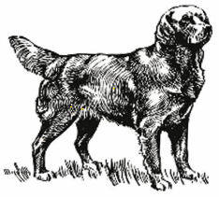
Golden Retriever

Club of Scotland

Name: .......…………………………………………………….…………………….

Address:…………………………………………………………………………………………………………………………………..………….………………………………………………………………………Postcode………………………………..
Tel No: …………………………… Affix: ………………………………………….
Email: ……………………………………………………………………………….
If you no longer wish to receive field trial entry forms, please tick here:

I enclose my subscription for:
Single Membership £11.00

Joint Membership £13.00

International Membership £23.00

Junior Membership (under 16) £2.00

Should you wish to pay by Bankers Order for 2023 please request a form.
PLEASE NOTE: IF YOU CURRENTLY PAY BY BANKERS STANDING ORDER PLEASE IGNORE THIS REMINDER

Signed: …………………………………………………..Date: ……………………

Please return this form to Fiona Walker
Fawnburnhead, Cardrona
Peeblesshire EH44 6PS
Email: fawalker@sky.com

