Golden Retriever Club of Scotland
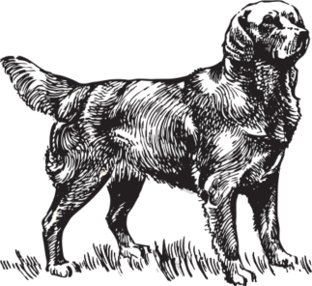
Honorary Secretary
Mrs. Carol Henry
Mousewater Cottage
Forth
South Lanarkshire
ML11 8ET
Tel:01555 812430
Email: secretarygrcs@btinternet.com
March 2024

Notice is hereby given that the Annual General Meeting of the Club will be held at:
Community Hall, Ravenstruther, Lanark Rd, Ravenstruther, Lanark ML11 7SS, on Sunday 21st of April 2024 at 10.30am.
Any member wishing to put a resolution of any kind to the meeting must do so in writing to the Secretary by 25th March 2024. Any resolution must be duly seconded by a current member.

Election of Office Bearers and Committee.
Vacancies will occur as indicated below. Nominations should reach the Secretary by 25th March 2024 signed by the proposer and seconder who must be current members. Proposers should ensure that they have the consent of the nominee before submitting the nomination.
Retiring members who offer themselves for re-election do not require proposers or seconders.

Nominations are invited for the Offices of President, Chairman and Vice Chairman.
President - Mr. Jim Richardson offers himself for re-election.
Chairman - Mr. Tom Gorrian offers himself for re-election.
Vice Chairman - Vacant: We would invite applications for this post
Treasurer - Mr. Douglas McGuffie does not offer himself for re-election.

There are a total of four vacancies which will occur on the Executive Committee of which retiring members: - Fiona Reid & Sharon McCormack offer themselves for re-election, Marie Grady and Kirsty Feasby, do not offer themselves for re-election.

Those members wishing to join the Committee, other than existing committee members offering themselves for election, are invited to include a short passage under the following headings. The number of years they have owned Golden Retrievers, the year they joined the GRCS, the involvement they have had with other canine clubs or charities, the responsibilities they have had in these organisations together with their main interest in the dog world by the 25th March 2024. All nominations should be proposed and seconded by current fully paid-up club members.

